EXPERIMENT 6

DML COMMANDS (COLLEGE SCHEMA)

Aim:

* Insert 5 instances into the tables created in experiment 5.
* Display the tables.
* Add attribute course to student table then insert values.
* Use update to set course for students.
* Delete an attribute.

**Procedure:**

**Code:**

* **ALTER TABLE student drop gender;**
* **INSERT INTO student values(255, "Leena S", "DBMS", 86, "A+", "777 Brockton Avenue, Abington MA 2351");**
* **INSERT INTO student values(255, "Leena S", "DAA", 34, "C", "777 Brockton Avenue, Abington MA 2351");**
* **INSERT INTO student values(255, "Leena S", "PPS", 34, "C", "777 Brockton Avenue, Abington MA 2351");**
* **INSERT INTO student values(255, "Leena S", "OS", 56, "B", "777 Brockton Avenue, Abington MA 2351");**
* **INSERT INTO student values(255, "Leena S", "Python", 98, "O", "777 Brockton Avenue, Abington MA 2351");**
* **INSERT INTO student values(234, "Rhea R", "DBMS", 94, "O", "30 Memorial Drive, Avon MA 2322");**
* **INSERT INTO student values(234, "Rhea R", "DAA", 64, "B+", "30 Memorial Drive, Avon MA 2322");**
* **INSERT INTO student values(234, "Rhea R", "PPS", 86,"A+", "30 Memorial Drive, Avon MA 2322");**
* **INSERT INTO student values(234, "Rhea R", "OS", 44,"C+", "30 Memorial Drive, Avon MA 2322");**
* **INSERT INTO student values(234, "Rhea R", "Python", 97, "O", "30 Memorial Drive, Avon MA 2322");**
* **INSERT INTO student values(675, "Raji C", "DLC", 90, "O", "700 Oak Street, Brockton MA 2301");**
* **INSERT INTO student values(675, "Raji C", "Analog Electronics", 87, "A+", "700 Oak Street, Brockton MA 2301");**
* **INSERT INTO student values(675, "Raji C", "Signal & System", 23, "F", "700 Oak Street, Brockton MA 2301");**
* **INSERT INTO student values(675, "Raji C", "ET", 33, "C", "700 Oak Street, Brockton MA 2301");**
* **INSERT INTO student values(675, "Raji C", "DSP", 73,"A", "700 Oak Street, Brockton MA 2301");**
* **INSERT INTO student values(474, "Diksha B", "DAA", 89, "A+", "66-4 Parkhurst Rd, Chelmsford MA 1824");**
* **INSERT INTO student values(474, "Diksha B", "DBMS", 45, "C+", "66-4 Parkhurst Rd, Chelmsford MA 1824");**
* **INSERT INTO student values(474, "Diksha B", "PPS", 43, "C+", "66-4 Parkhurst Rd, Chelmsford MA 1824");**
* **INSERT INTO student values(474, "Diksha B", "OS", 55, "B", "66-4 Parkhurst Rd, Chelmsford MA 1824");**
* **INSERT INTO student values(474, "Diksha B", "Python", 83, "A+", "66-4 Parkhurst Rd, Chelmsford MA 1824");**
* **INSERT INTO student values(747, "Anjali R", "DLC", 90, "O", "591 Memorial Dr, Chicopee MA 1020");**
* **INSERT INTO student values(747, "Anjali R", "Analog Electronics", 98, "O", "591 Memorial Dr, Chicopee MA 1020");**
* **INSERT INTO student values(747, "Anjali R", "Signal & System", 100, "O", "591 Memorial Dr, Chicopee MA 1020");**
* **INSERT INTO student values(747, "Anjali R", "ET", 78, "A", "591 Memorial Dr, Chicopee MA 1020");**
* **INSERT INTO student values(747, "Anjali R", "DSP", 87, "A+", "591 Memorial Dr, Chicopee MA 1020");**
* **SELECT * from student;**

* **INSERT INTO faculty values(2425, "Sheela S", "DBMS", 100, NULL);**
* **INSERT INTO faculty values(2342, "Ritu Singh", "DAA", 100, NULL);**
* **INSERT INTO faculty values(6475, "Vidhya T", "OS", 100, NULL);**
* **INSERT INTO faculty values(4724, "Madhavi R", "PPS", 100, NULL);**
* **INSERT INTO faculty values(7147, "Jasveer K", "PYTHON", 100, NULL);**
* **INSERT INTO faculty values(2426, "Renu M", "Analog Electronics", 100, NULL);**
* **INSERT INTO faculty values(2312, "Rita J", "DLC", 100, NULL);**
* **INSERT INTO faculty values(6405, "Arha S", "DSP", 100, NULL);**
* **INSERT INTO faculty values(4794, "Madhu L", "ET", 100, NULL);**
* **INSERT INTO faculty values(7117, "Priya J", "Signal & System", 50, NULL);**
* **SELECT * from faculty;**
* **INSERT INTO department values(5341, "CSE", "A",3, 100, 2);**
* **INSERT INTO department values(5342, "ECE", "A", 2, 50, 2);**
* **SELECT * from department;**
* **ALTER TABLE activity add faculty_name varchar(50);**
* **INSERT INTO activity values(1, "sports", 5, "badminton", "Vidhya T");**
* **INSERT INTO activity values(2, "art", 4, "mural", "Sheela S");**
* **INSERT INTO activity values(3, "music", 4, "carnatic", "Ritu Singh");**
* **INSERT INTO activity values(4, "poetry", 5, "haiku", "Madhavi R");**
* **INSERT INTO activity values(5, "dance", 3, "western", "Jasveer K");**
* **SELECT * from activity;**

**OUTPUTS:**

**Student table:**

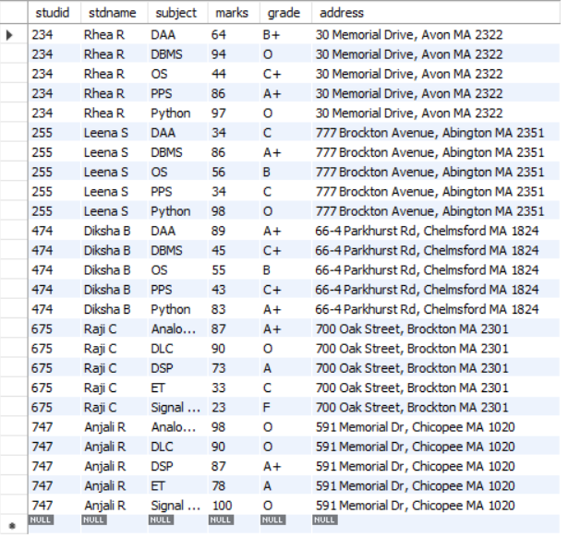

**Faculty table:**

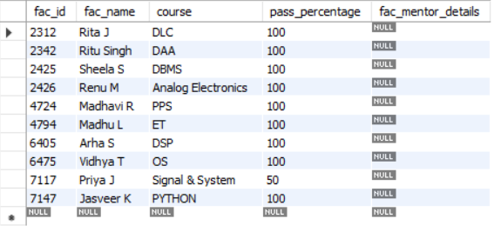

**Department table:**

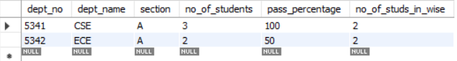

**Activity table:**

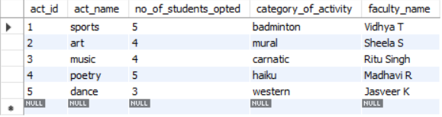

**Code:**

* **update student set course = "CSE" where studid in (select * from (select studid from student where subject = "DBMS") tmp);**
* **update student set course = "CSE" where studid in (select * from (select studid from student where subject = "DSP") tmp);**
* **select * from student;**

**Output:**

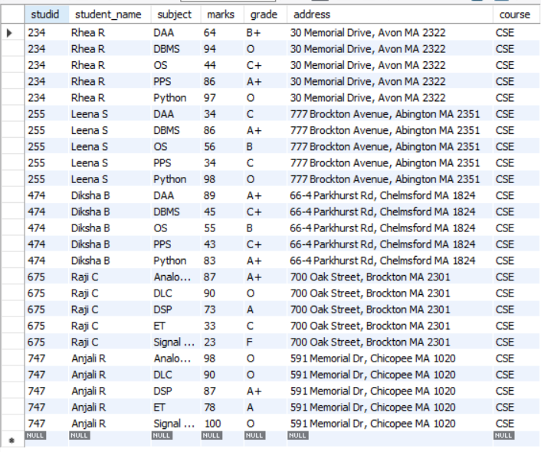

**Code:**

* **alter table faculty drop column fac_mentor_details;**
* **select * from faculty;**

**Output:**

